2022 Module Handbook
Project Management for Computing and Advanced Engineering
School of The Built Environment Engineering & Computing
CRN COMP753-Project Management 11692
Level 7 Masters
Semester 2 (20 Credits)
Contents
1 What this Module is About 1
1.1 Introduction from the Module Leader 1
1.2 Module Aims 1
1.3 Module Learning Outcomes 1
1.4 Module Learning Activities 1
1.5 Graduate Attributes Developed and Assessed 1
1.6 Communication 2
2 Weekly Schedule 3
3 Key Resources to Support Learning 5
4 Assessment 5
4.1 Assessment Summary 5
4.2 Assessment Details 7
4.3 Feedback on Your Assessments 13
5 Understanding Your Assessment Responsibilities 13
6 Your Feedback on the Module 14

Student Name ____________________________________________________________
Email Address ____________________________________________________________
Course ___MSc Various _______________________
Group ___Construction and Project Management ____________________
Module Tutor ___John Heathcote_______________________________________
Tutor’s Email Address __J.Heathcote@LeedsBeckett.ac.uk_____________________
Communication Protocol: module staff will reply to student questions within a reasonable time but this will normally be within office hours only. Students are advised to check this handbook and also to see if there are any online/noticeboard announcements or FAQ answers that deal with their enquiry before contacting staff.

What this Module is About

Introduction from the Module Leader
Hello MSc students. This module about the management of projects is delivered to you by, Hadi Kazemi, Mark Laurillard, Professor Mohammed Dulaimi and John Heathcote. As a team we have a broad set of industry experiences including, I.T., Business Change, Innovation, Civil Engineering, Construction, MEICA and Research projects. We are all tutors in the School and belong to the Project Management and Construction Engineering section.
We are active researchers in things to do with managing projects, such as, new approaches to planning, innovation, smart cities, procurement and contract strategies, project methodologies and project tools, and team working and human behavioural economics.

Students who study this module should expect to achieve and advanced level of understanding and critical analysis of Project management and its relationship to projects in our specialist environments.

Preamble to the module
This module content aims to equip students with an insight into the challenges of managing projects in practice. The theoretical development of project management is acknowledged to be at an early stage in its development. This is an exciting time to be studying the management of projects because a plurality of perspectives have emerged from research work based in practice. This helps to provide an insight that demystifies approaches to managing projects. Leading research identifies perspectives of the Control paradigm, the Engineering paradigm, and Hard and Soft paradigms. Previously, and still dominant in practice is PM’s control paradigm. The Control paradigm dominant view is likely to inform your starting idea of what PM is. It sees project management as being about setting objectives and managing the project to deliver on time and to budget. While important, this perspective needs expanding. Associated with the control paradigm, is the Engineering paradigm of projects. This is an enticing view, especially for engineers! This Engineering paradigm sees projects as creating things, additionally project management largely arises from engineering and particularly I.T. at the end of the twentieth century. However, increasingly researchers in practice show that projects’ issues arise, not from the physical assets, but from how they are viewed and exploited. In short, the ‘value’ that can be extracted for the intended beneficiaries. Put another way, we do projects not for the engineering they produce, but for the benefits those assets can bring, once exploited. This broadens our understanding of what is important in the project and what other things need to be considered, and of course the skills set required of the project manager and team. Pollack (2007) contrasted this development by contrasting the two approaches as being hard (engineering and control) and soft (social contexts and decision making). Here is his conceptual model ...

Fig. 1.0 Pollack’s conceptualisation of the hard and soft paradigms of project management.
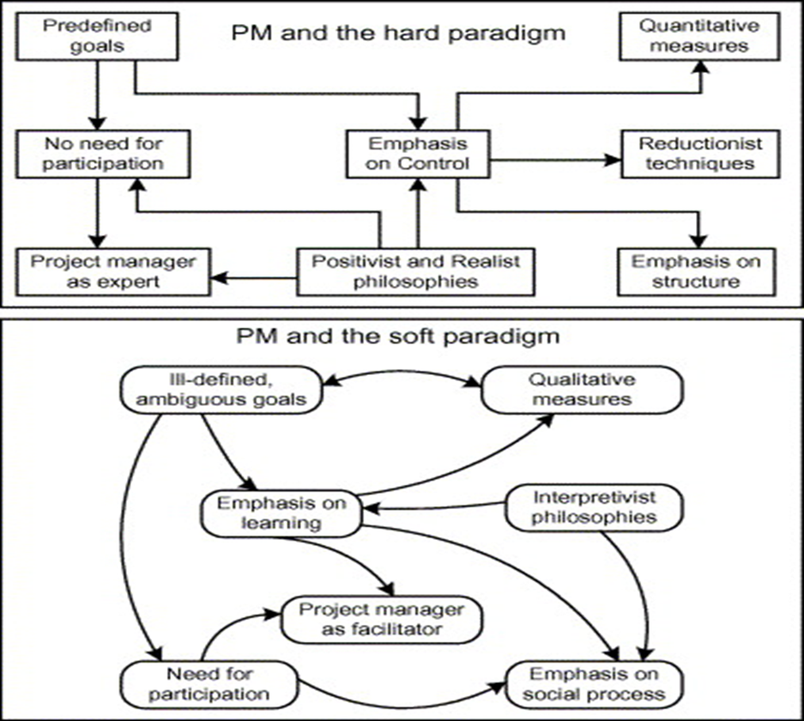

Module Learning Outcomes
This module aims to assist students in developing the learning objectives of:
LO1: Specify the role and goal of Project Management, and its key functions, to develop a project management strategy which specifically addresses the needs and priorities of a specific client/organisation.
LO2: Critically evaluate the tools, techniques and the role of the Project Manager in managing project development.
LO3: Synthesise the variety of Project Management methodologies used for monitoring and controlling projects across technology related areas and projects.
LO4: Critically analyse case studies associated with contemporary project management issues.

Module Learning Activities
This module will each of the 12 weeks of the semester, will have ...

An online element. This involves, directed preparation work
an hour’s recorded lecture, or on-line lab, or ‘flipped classroom’, (‘Flipped classrooms’ may include some you-tube lectures and reading, or exercises). Also,
A two hour in-person lecture/seminar.
On Tuesday afternoons. (This will appear on your student timetable).

Key Reading has been curated for you and is in the MyBeckett VLE (virtual learning environment).

Each week is set out in MyBeckett (VLE), students need to get familiar with this.
All lectures will be streamed and recorded.
Each week’s topic WILL INFORM YOUR Coursework development! All of it counts towards your assessment.

Graduate Attributes Developed and Assessed
This module will provide you with an insight into the challenges in developing and managing projects in practice.
Research work will be undertaken into case projects of your choice.
Academic primary and secondary research and the writing up of research will be skills that are developed.
More information on graduate attributes is available here:
https://skillsforlearning.leedsbeckett.ac.uk/local/graduate_attributes/category_homepage.shtml
Relevant information is also available within the Course Specification. The Course Specification is located with your Course Handbook on the Course Handbook web page: http://www.leedsbeckett.ac.uk/studenthub/course-handbooks/

Communication
Announcements for pre-reading activities will be made via My-Beckett.
Several templates, the case studies we use in class, and examples will be available for you to use in My-Beckett.

You must notify your Course Administrator if you are absent for more than one day (for example for an interview, emergency unforeseen circumstances, or for compassionate leave). If you are going to apply for mitigation you will need to provide written evidence of the reason for your absence (see section 3 of your Course Handbook).

Calendar and Timetable

This module will start on w/c 31st January 2022 and run until w/c 2nd May 2022 ...

In-Person Lecture/Seminar Classes (at the time of writing) are scheduled for TUESDAYS 13:30 - 15:30 in-person in HC JGG10 (LTB).

There are two weeks for Easter break in April, running from the 9th to the 24th April.

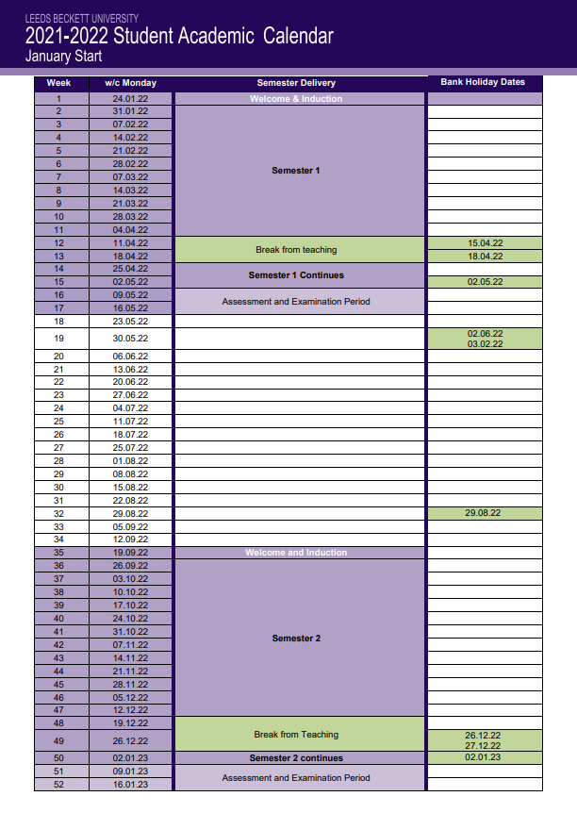

Weekly Schedule
Week | Lecture/Seminar Classes are on Tuesdays at 13:30 - 15:30 in-person HC JGG10 (LTB) | Recorded Lectures, Flipped Classrooms and Labs | Tutor | Reading, Papers & Cases
1 | Strategies, Programmes and Portfolios. Cognitive Biases in Decision Making. | Introduction to assignments - John | Mark Laurillard  and John Heathcote | Each week you will be provided with recommended reading. You may wish to read ahead. This reading will be important to your individual exam based assignment.
2 | Lifecycles, Methodologies Waterfall and Agile approaches | Pre-Recorded item | Mark Laurillard
3 | Quality Management tenets, that underpin project methodologies | Governance model – John | Hadi Kazemi
4 | Value Management and Requirements Planning | Pre-Recorded item | Hadi Kazemi
5 | Stakeholder Management/Engagement Client and Customer | Pre-Recorded item | Mohammed Dulaimi
6 | The Business Case and Benefits Management | Pre-Recorded item | Mark Laurillard
7 | Planning techniques - Planning Fallacy | MSProject use of planning software – John The Risk Matrix – The CashFlow – John (Gergerinzer You-tube) | John Heathcote
8 | Research on planning: ‘Modelling for Analysis’ | MSProject WBs and Tracking tables – Theory of Constraints demo - John | John Heathcote
9 | Procurement and Contract Strategies | Heathcote et al (2019) Illustrating Game laying on Construction Contracts – John | John Heathcote and Mohammed Dulaimi
10 | Leadership and Team building | Reading of the ‘Myth of Teamworking’ NOTES – John  Good meeting practice - John | John Heathcote
 | Easter Two Week Vacation
 | Easter Two Week Vacation
 | Assessment Part One Group Report Hand in Week 11 (25th April 2022)
11 | Innovation | Pre-Recorded item | Mohammed Dulaimi
12 | Assignment revision surgery | Pre-Recorded item | John Heathcote and Mark Laurillard
13
14 | Assessment Part Two Online Open Book Exam in Week 14 (16th May 2022)
A student guide on contact hours is available here: www.qaa.ac.uk/en/Publications/Documents/contact-hours-student.pdf.

Key Resources to Support Learning

This module
Has a prepared reader for you, see the folder in MYBECKETT.
Additionally, the template examples we look at in class will also be available on MYBECKETT, and a template programme example which you may wish to use of.
Also we will look at research work into programme related issues that is either in progress or has been submitted by your peers. This work can be cited also.
Do refer to the examples we looked at in class, as these intended to help you think about what will work in practice and what might not be practical.
All disabled students requiring additional support or alternative arrangements must declare and provide evidence of their disability to the Disability Advice Team as early as possible: www.leedsbeckett.ac.uk/studenthub/disability-advice.

Each week’s learning resources includes:
- A weekly folder on a specific topic.
  - With sub-folders containing
    - Pre-Reading,
    - Recorded lectures, Flipped Classroom materials.
    - Any slides, notes or reading associated with the in-person lecture.

Assessment
Assignment Briefs
Part 1.0
How PM tenets might be applied to a project case study.
Working in a self-organised group of three students ...Select and Describe a case study project, it’s challenges and your recommended project strategy for it.
50% grade for module,
c3,000 words
Part 2.0
Based on reading and course materials provided …
How and why (to what purpose) is PM evolving?
Answer 4 of 6 questions in a timed exam
50% grade for module,
c3,000 words

Part One component Hand in
Week 11 (25th April 2022)
Part Two Hand in
Week 14 (16th May 2022)

And in more detail, over the page ...

Part 1.0 50% of the module grade comes from this assignment. (Due week 25th April 2022)
How PM tenets might be applied to a project case study.
Working in a self-organised group of three students ...Select and Describe a case study project.
Identify: The Strategic benefits/goals; Business case; strategic risks and issues and project risks and the project delivery strategies in the planning strategy and the team/contract strategy.
Use the RADIO log provided to capture your detailed group notes.
Create a Gantt schedule plan, And Cashflow model to assist with analysis and modelling.
Keep your meeting notes.
Title:
Student Authors:
How the application of PM tenets addresses the issues that (did or might) lead to failure. (Include illustrations, see example provided)
Short summary of the project case (300 words)
Analysis of Risks to Project Success (1,000 words)
Stakeholders
Strategic Market context
Time and Cost challenges
Proposed Project Strategy to Mitigate identified Risks to Value (1,000 words)
Summary (700 words)
References
Appendices of: Screenshots of RISK-RADIO matrix; Gantt; Cashflow and Meeting Notes.

50% grade for module, c3,000 words excluding Appendices.

Part 2.0 50% of the module grade comes from this assignment. (Due week 16th May 2022)
Based on reading and course materials provided …
How and why (to what purpose) is PM evolving?
Individual Assignment –
Answer 4 of 6 questions in a timed ‘open book’ exam
50% grade for module, c3,000 words
Choose from, see list at the end of the document for the draft examples:

Assessment Summary
Assessment 1 of 2
Assessment Method: |  | Re-assessment Method:
Coursework | Group Academic Report |  | Complete the original academic report individually, to a standard sufficient to pass.
Assessment Date and Time: | 25th April 2022 18:00pm | Re-assessment Date and Time: | TBA  Post exam board
Feedback Method: | In writing via email, and in Turnitin | Feedback Method: | General feedback for the whole cohort, and personally targeted feedback in the feedback sections in Turnitin.
Feedback Date: | 25th May | Feedback Date: | TBA
Learning Outcomes Assessed: | All Project Development L.O.s

Assessment 2 of 2
Assessment Method: |  | Re-assessment Method:
Coursework | Individual Exam Open Book, timed.  Answer 4 of 6 questions in a timed ‘open book’ exam |  | Retake a formally arranged exam, to a standard sufficient to pass.
Assessment Date and Time: | 16th May 2022 Time to be determined | Re-assessment Date and Time: | TBA  Post exam board
Feedback Method: | In writing via email | Feedback Method: | General feedback for the whole cohort, and personally targeted feedback in the feedback sections in Turnitin.
Feedback Date: | 16th June | Feedback Date: | TBA
Learning Outcomes Assessed: | All Project Development L.O.s

Assessment Details
Coursework
Academic essay to the assignment format, available on My-Beckett.
Submission
This module requires you to submit your work online.
You MUST submit your work through My-Beckett using the link set up by the tutor
Receipt of your work will be recorded.
Your "Turnitin assignments" in My-Beckett can be set up so that you can check your assignment yourself as you submit it. This checking is done by creating an "Originality Report". If this report shows that there are some problems with your work, such as un-cited quotations, you should be able to make corrections and re-submit the work again before the due date. More information about Turnitin is available online here: http://libguides.leedsbeckett.ac.uk/mybeckett/turnitin

Please note: Tutors will follow up any suspected unfair practice found after the submission date as per University policy. Late penalties will apply as per University Regulations.

Particular Instructions to Students
A zero mark will be awarded for: non-submissions or for situations, where the student fails to address the assignment brief (e.g. answers the wrong question) and/or does not achieve the learning outcomes for the module)
Please read carefully the assessment and marking criteria on pages 11 and 12:

Course Title(s): | MSc Various
Module Title: | Project Management for Computing and Advanced Engineering | Level: | 7
Assessment Title: | Group Academic Report | Weighting: | 50

Criteria and Weighting | 100-70 | 69-60 | 59-50 | 49-40 | < 40 fail
Summary of Case study and Analysis of the Risks to Project Success. | Your review will incorporate a critical evaluation of the risks to adding value considering the constraints on the project. Understanding the project by identifying the various stakeholder interests. Team takes an open system perspective, to make the project open for innovation. | Your review will incorporate a critical evaluation of the risks to adding value considering the constraints on the project. Understanding the project by identifying the various stakeholder interests | The review undertakes a risk identification approach, and some important risks are identified, that allow a project strategy to be developed. | Risks limited to project level risks and avoids strategic risks to value being added. | An incomplete description of the case study, limiting the ability of the team to identify relevant risks to the project.
Proposed Strategy to Mitigate the Identified Risks | A coherent project strategy, with possible options is developed, and addresses the risks identified to best ensured a flexible and innovative risk mitigation approach. | A coherent project strategy, with possible options is developed, and addresses the risks identified | A project strategy is evident, and links to risks identified are identifiable. | A partial solution that addresses some of the identified risks is communicated. | A limited solution that addresses some of the identified risks is partially communicated.
Synthesis of argument in final Summary | The argument is developed to include some insight that allows for consideration for conference publication. The application for practice is presented to a quality that can inform practice, perhaps in a particular setting. Scientific approach is rigorous. | The argument is developed and flows to include some insight. Issues are explicitly developed.  There is clarity in the finding’s presentation. | The argument is developed somewhat. Issues can be implied.  Findings are presented. | The argument does not flow and is piecemeal. Tends towards notes. | Argument to answer the assignment brief question, about its current limitations and possible future applications for practice is not considered.  A zero mark will be awarded for: non-submissions or for situations, where the student fails to address the assignment brief (e.g. answers the wrong question) and/or does not achieve the learning outcomes for the module
Presentation, Conformity to required format. Citation to Harvard | Presentation is succinct.  Format is adhered to.  Citation is consistent and complete. | Format is adhered to.  Citation is consistent and complete. | Format is adhered to.  Citation is consistent and complete. | Limited conformity to required format.  Some citation but incomplete. | Not conforming to the required format.  Not citing sources.

Course Title(s): | MSc Various
Module Title: | Project Management for Computing and Advanced Engineering | Level: | 7
Assessment Title: | Open Book Online Timed Exam | Weighting: | 50

Criteria and Weighting | 100-70 | 69-60 | 59-50 | 49-40 | < 40 fail
Answer 4 of 6 Option questions  Each Answer, graded ... | A complete answer, referring to issues raised in the module coursework and reading and considering several relevant perspectives.  Argument is coherent, succinct, and clear. A critical evaluation of the relevant issues.  Brief Illustrations may be provided to support the argument(s) made. | A coherent answer is developed referring to issues raised in the module coursework and reading. | A partial but relevant answer is developed referring to issues raised in the module coursework and reading. | A brief answer considering some relevant aspects of the question. | Argument to answer the assignment brief question, about its current limitations and possible future applications for practice is not considered.  A zero mark will be awarded for: non-submissions or for situations, or unanswered questions. Zero marks will be applied where the student fails to address the question (e.g. answers the wrong question) and/or does not achieve the learning outcomes for the module

Feedback on Your Assessments
Feedback forms a large part of your learning experience and is vital to your personal and professional development. We have worked with our Student Union to produce the following guidance, which explains the benefits of feedback, the forms it may take and how to use it.
https://www.leedsbeckettsu.co.uk/studentvoice/coursereps/toolbox/feedbackpack
Make use of the seminar discussions in class to inform your development of the paper. Make notes (especially on the exercises and the outcomes from your group and others), feel free to record these discussions if that helps you. Feedback can be sought from the tutor in these wrap up seminar sessions, and you are also able to email the tutor with thoughts or questions you might have, on this topic.
Your development of the coursework should progress throughout the module and feedback in seminar is available to you as you develop those drafts. This iterative development of your assignment plan is encouraged.

Understanding Your Assessment Responsibilities
Extenuating Circumstances and Mitigation
If you are experiencing problems which are adversely affecting your ability to study (called 'extenuating circumstances'), then you can apply for mitigation. You can find full details of how to apply for mitigation at: www.leedsbeckett.ac.uk/studenthub/mitigation.htm.
The University operates a fit to sit/fit to submit approach to extenuating circumstances which means students who take their assessment are declaring themselves fit to do so. More information is available at the above link and here: http://www.leedsbeckett.ac.uk/studenthub/examinations/
Late Submission
Without any form of extenuating circumstances, standard penalties apply for late submission of assessed work. Full details of the penalties for late submission of course work are available at www.leedsbeckett.ac.uk/public-information/academic-regulations.
Academic Misconduct
Academic misconduct occurs when you yourself have not done the work that you submit. It may include cheating, plagiarism, self-plagiarism, collusion and other forms of unfair practice. What is and what is not permitted is clearly explained in Factsheet for Students which is available to view at: www.leedsbeckett.ac.uk/studenthub/academic-integrity.
There are a range of resources available to help you understand what is and what is not permitted and how to use other people’s ideas in your assessed work. These include the Skills for Learning website which can be found at http://skillsforlearning.leedsbeckett.ac.uk
The serious consequences of plagiarism and other types of unfair practice are detailed in the Academic Regulations at www.leedsbeckett.ac.uk/public-information/academic-regulations.

Your Feedback on the Module
A mid-module review will be timetabled into your module by week 7. This is an opportunity to resolve modular issues promptly early on in the module. In addition, you will have the opportunity to feed-back formally at the end of your module. These comments will be reviewed by your course team, and some may be considered via the course monitoring and enhancement process, in which your Course Representative is involved.

DRAFT Exam Questions, likely to be changed/refined before the exam ...

QUESTION OPTION 01: - Project Management is often regarded as a suite of 'tools and techniques' deployed to assure the stakeholders of project 'success.' Provide an analysis of what project 'success' is seen as, in particular from the perspective of the project manager and from the stakeholders. Discuss the extent to which reliance on 'tools and techniques' can be an adequate measure of a Project Manager’s success. (25 marks)

QUESTION OPTION 02: - Analyse the apparent 'trade off' between the ability of a project manager to successfully deploy a methodological approach to project delivery and their ability to successfully lead a diverse project team. (25 marks)

QUESTION OPTION 03: Your SME company has a Research and development section, and the department is looking for direction about what to do next. Propose a process for portfolio and programme management. And suggest how this innovation might also be supported from a team project perspective too. (25 marks)
QUESTION OPTION 04: Why is ‘project quality’ important in a project? Outline the main tools and techniques are available to measure quality in a project. Which international standard(s) help organisations manage quality and how can they help to improve projects in computing/IT, creative technology or engineering projects? Use illustrative diagrams and examples as appropriate. (25 marks)
QUESTION OPTION 05: “Proactive Stakeholder management is the key to successful Creative Technology, Computing, IT-related & Engineering projects in the 21st century”
Critically discuss this statement, outlining the importance of stakeholders to projects, how they might be negatively and positively affected, and how successful stakeholder management strategies may influence the other knowledge areas of PM using illustrative examples and case studies as appropriate. (25 marks)

And ...

QUESTION OPTION 06: Planning is closely associated with the management of projects. And schedule planning is a part pf that, (along with 'requirements planning, and resource planning, cost planning and risk management), and the Gantt chart is the physical manifestation of the planning artefact.
Plans change during delivery, which leads some people to think the schedule plan has less utility in practice.

What advantages might a schedule plan/model offer to those managing projects? (25 marks)

Use the picture below to help your description, if it helps.

